Court File: T-1450-15

FEDERAL COURT OF CANADA

BETWEEN:

Radu Hociung

Plaintiff

and

Minister of Public Safety and Emergency Preparedness
and
Canada Border Services Agency
and
Her Majesty the Queen in Right of Canada

Defendants

LETTER TO THE COURT
Re: Further Additional Representations

Radu Hociung
246 Southwood Drive
Kitchener, Ontario
N2E 2B1
Tel: (519) 883-8454
Fax: (226) 336-8327
email: radu.cbsa@ohmi.org

TO:
The Registrar
Federal Court of Canada
180 Queen Street West
Suite 200
Toronto, Ontario
M5V 3L6

AND TO (by email):
Derek Edwards, Counsel to the Defendant
DEPARTMENT OF JUSTICE
Ontario Regional Office
120 Adelaide Street West
Suite 400
Toronto, Ontario
Tel: (647) 256-7493
Fax: (416) 973-5004
June 16, 2020

Mr. Justice Gleeson,

Having conferred with the Defendant as per your June 9, 2020 direction, the plaintiff makes the following further additional submissions:
- The parties are in consensus that the claims relating to threats of violence cannot be dismissed.
- The parties are not in consensus on any of the remaining claims and issues on either of the two motions.
- The “binding nature of the Federal Court of Appeal's” judgments is that both judgments on the two motions are quashed and the motions must be redetermined. The Federal Court of Appeal exercised its power to quash the Federal Court judgment and return the motions to the Federal Court, and as a consequence, the Federal Court must redetermine the motions. The FCA did not order the Federal Court to do anything; an order could be considered “binding”.

New Evidence

- At the Summary Appeal, the defendant was asked by the court directly whether there is any evidence that the coins are “goods” for the purposes of the Customs Act. The Defendant admitted that there is no such evidence.
- This admission is now new evidence on the motion for summary judgment, and must be considered by the Federal Court in redetermining the summary motion.

Summary Motion

- The Federal Court of Appeal identified two issues at paragraph 20 of its A-102-18 judgment. It agreed with the appellant on issue “A”, and disagreed on issue “B”. Accordingly, it concluded at paragraph 64 that “the appeal should be granted in part”. That means, granted on issue A and not granted on issue B. On both issues, the Appellant sought to have your Motion Judgment quashed, so regardless which part of the appeal was successful, the outcome is identical - your Motion Judgment is quashed. While “theoretically”, the appeal was granted in part, the practical outcome is that your judgment is quashed in its entirety, as it had only one part, ie, to “dismiss the action it its entirety”
- Additionally, the Federal Court of Appeal opined that the Federal Court could, on redetermination, reiterate its finding that a contravention occurred, and that the CBSA was legally entitled to seize the coins under the Customs Act. The question is which claims and relief can properly be dismissed on this basis? In other words, on which claims are these the determinative issues?
- The opinion that a contravention occurred is not binding on the Federal Court. It is merely jurisprudence. Ie, The Federal Court cannot reason “a contravention occurred because the FCA said so on appeal from the Federal Court's earlier reason”. The circular logic that would make this reason invalid is readily apparent.
- Furthermore, jurisprudence is often faulty, or outright wrong. This court's own initial judgment, and every Appeal Court judgment that is overturned on Supreme Court appeal, are examples of jurisprudence that is faulty in some way, although it may contain some correct elements. Faulty jurisprudence is not corrected, nor expunged in some way, but remains for ever in the public record. Conflicting jurisprudence exists is is widespread, and is in fact useful to illustrate incorrect ways to make judgments for posterity. To interpret that any piece is jurisprudence is “binding” on a Court would be thoroughly misguided.
- However, nothing in the Federal Court of Appeal judgment prevents the Federal Court from reaching the same conclusion it did initially, or giving the same reasons. Given that you consider yourself “seized” to this proceeding, it would be unreasonable to expect you to reach different conclusions on redetermination of the same representations of the parties.
- If a different judge were to determine the Motion, he would be bound to his oath to “dully and faithfully execute his powers and trusts as judge to the best of his skill and knowledge”, and to the principles of judicial independence. Integrity dictates that a judge use his best skill and knowledge, and not be bound by the opinion of other judges. In other words, you may reach the same conclusion as the jurisprudence if that is the best of your skill and knowledge, but apply your own skill and knowledge, you must.
- The plaintiff reiterates his position stated in his responding motion record, that with respect to the Ministerial Decision, an appeal to the Federal Court from a Minister's Decision is a request for judicial review of the Minister's Decision. The Minister's Decision is to be reviewed. The Court is not required, nor permitted by the Customs Act, to make a Minister's Decisions on different evidence. The Court must review the Decision made by the Minister on the evidence that was before the Minister. The standard of review is one of reasonableness.
- On a reasonableness standard, a decision must exhibit the “existence of justification, transparency and intelligibility within the decision making process”, as you quoted Dunsmuir yourself in 2019 FC 345 at para 22. The Supreme Court of Canada updated the standard of review more recently in Vavilov, 2019 SCC 65 (CanLII), par. 86, and requires decisions to not only be justifiable, but also justified.
- The Minister's Decision is based on the coins being “not currency”, which is the same argument the Applicant makes on his motion. You found that this basis is untrue, that the coins are in fact currency. However, you proposed an alternative justification on behalf of the Applicant, in Excise Tax Act definition of “money”. If this were the true justification for the Minister's Decision, the Minister himself was required to articulate it in his Decision. If it the ETA definition of “money” were helpful, it could be said that the Decision was “justifiable”, however, it was not “justified”.
- The simple fact that the Minister did not articulate the justification (which you believe to be the true reason for his Decision) means that the Decision itself is unreasonable, and cannot stand, as the Supreme Court tells us in Vavilov para 86.
- At paragraphs 29 and 30 of its A-102-18 judgment, the FCA says that the Federal Court cannot grant the order it did on a basis that a contravention had occurred. You'd have to prove that every claim can be dismissed on this basis, or find some other bases for dismissal. Specifically at para 30, via para 64, it gently advises the Federal Court on what order can be granted on this motion.
- By pointing to Rule 215(3), the FCA not only reminds the Federal Court that it must obey the Rules, but recommends dismissing the motion in “whole or in part” (Rule 215(3)(b)). Rule 215(3)(a) is not a possibility, because this is not a motion for summary trial.
- The motion only contains one part, as it requests only one thing from the Court, namely “Summary judgment dismissing this action in its entirety”, which means there is no part of the motion that would remain if “dismissing the action in its entirety” is not possible.
- The defendant made representations to support this exact request, that the “action be dismissed in its entirety”, and these were the representations that the Plaintiff was required to rebut. A judgment other that what was requested would be inappropriate, as it was neither supported by the Defendant's representations, nor did the Plaintiff have the opportunity to oppose it.
- The Defendant's representations were, in short, that on an Action pursuant section 135, only one claim can be made, and therefore all other claims should be struck. This is precisely the basis on which this Court initially dismissed the action. Not only does the Defendant now admit that at the very least the “threats of violence claim” cannot be dismissed, but the Defendant's “one claim action” argument was demonstrated on Appeal to be wrong. Given that the basis on which the requested relief was partially admitted to be incorrect, and partially proven to be incorrect, it is impossible, notwithstanding new judicial magic, to conclude that the summary motion can be anything but dismissed.
- The Defendant has encountered the “all or nothing problem” in his Motion to Strike the Statement of Claim in its entirety. That motion also failed because the Defendant did not take a surgical approach, where only some portions were sought to be struck; the only relief sought was to strike the claim in its entirety. The motion judge even commented that perhaps at a future summary disposition, the surgical approach could be taken. However, the Defendant once again seeks a total dismissal based on one single “silver bullet”.
- The Federal Court of Appeal was also irritated by the Defendant's approach, as it noted at para 11 of the A-102-18 reasons:
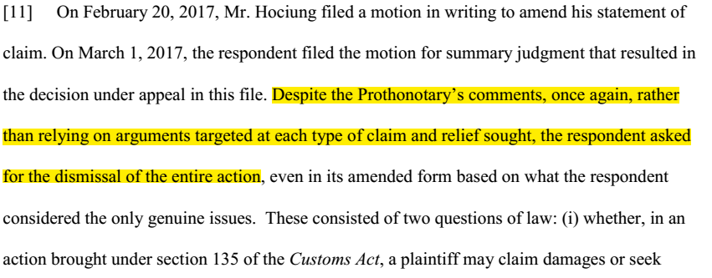
- As the parties are in consensus that the claim relating to threats of violence cannot be dismissed, and the Defendant is aware of the procedural practice whereby he must ask more precisely what relief he seeks, there should be no doubt that this motion cannot be granted. This conclusion does not require evaluating any other issues.
- The fact that the threats of violence cannot be dismissed turns out to be the “silver bullet” that kills the motion for summary judgment, even though it can properly be dismissed even by properly evaluating the other issues.
- With respect to the claims regarding fraud, the issue before the court is “Is it certain that the individuals did not commit fraud?”. The evidence before the court shows that the plaintiff was deprived of a large sum of currency based on the representation that it was not currency. The deprivation is not in dispute, although it is described as “seizure”, and the misrepresentation was in dispute, but you have already proven it. The Customs Act does not permit those individuals to commit fraud or other crimes in the event that a non-report contravention occurred.
- All the claims and remedies sought on the Statement of Claim remain in effect, in the plaintiff's view.
- The Federal Court needed to only consider paragraphs 11, 29 of the Summary Appeal reasons, and paragraph 8 of the Amendment Appeal reasons to conclude that the Motion for Summary Judgment cannot be granted. No additional representations were necessary to reach this conclusion.
- The Court may allow the Defendant to make a new Motion for Summary Judgment, identifying clearly which claims he wants dealt by summary judgment, and rely on arguments targeted at each claim. The Defendant is required by the Rule 213(2) to obtain leave of the Court in order to bring a further motion for summary judgment.

Amendment Motion

- On the Amendment motion, the Federal Court of Appeal exercised its power to quash the Federal Court's judgment, and return the matter to the Federal Court for redetermination.
- As on the Summary Appeal, the FCA did not order the Federal Court to do anything, and there is nothing binding.
- The Federal Court's of Appeal opines at para 9 that “although the majority of the amendments could be dismissed by the Federal Court, it could not dismiss them all”.
- The Appeal judgment identifies two potential reasons (A-101-18 reasons paras 5-6 and 7) for which some amendments could be struck, and one reason (para 8) which prevents other amendments from being struck.
  - “Amendments in tort clearly have no chance of success”.
    - This is incorrect. The correct way to phrase it would have been “the amendments in tort have a chance of success equal to the chance of success on the judicial review claim”, in other words, if the judicial review can succeed, then so can the amendments in tort. Since the judicial review is statutorily allowed, it means it has some chance of success, otherwise the possibility of review would not exist in the Customs Act. Conversely, if the judicial review claim cannot be struck, neither can the amendments in tort.
    - However, the Plaintiff took the additional view, in his Reply on the Motion record, that all Crown Servants (Customs Officers) named in the claims have committed fraud. The test on amendments is that if a claim could not succeed even if it can be proven, then it must be struck. For instance, a claim brought to a court without jurisdiction would not succeed, even if it can be proven, and must be struck. It is not a test seeking to exclude from determination matters which prima facie appear hard to prove.
    - Furthermore, In order to prove that the officers are shielded by the Customs Act provisions, the Crown would have to prove that the alleged misrepresentations (that the coins are “not currency”), fall within those subject to statutory protection, ie, that the misrepresentations are within their duties under the Customs Act. The applicable jurisprudence is Croft v. Durham (Regional Municipality) Police Services Board, 1993 CanLII 5444 (ON SC) at paras 11-14. It would be of assistance to envision a more extreme scenario, such as the George Floyd vs Derek Chauvin, the ex-police officer alleged to have murdered Mr Floyd under the guise of arresting him. In that case, assuming that the elements of murder can be proven, does the ex-police officer benefit from statutory protection? Does his duties include murdering people? If yes, then the claim may be struck. In the present proceeding, if the duties of Customs Officers includes fraud, then any claim for relief would be limited to the protection Customs Act s. 106, and, if statutorily barred, it would not succeed, even if the fraud can be proven, and should be struck.
  - Lack of “inherent jurisdiction”.
    - The Federal Court of Appeal is correct in that the the source of criminal jurisdiction of Federal Courts is not inherent. However, the Federal Courts have statutorily-granted jurisdiction thanks to sections 3-4 of the Federal Courts Act. I will quote the Criminal Code s. 468 and the Federal Courts Act s. 4 below, in close proximity, and highlight the relevant language, to demonstrate this fact:
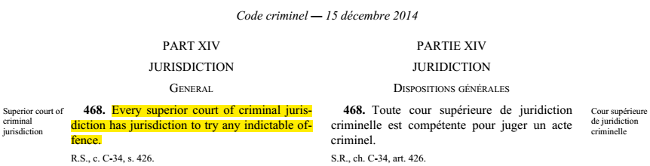
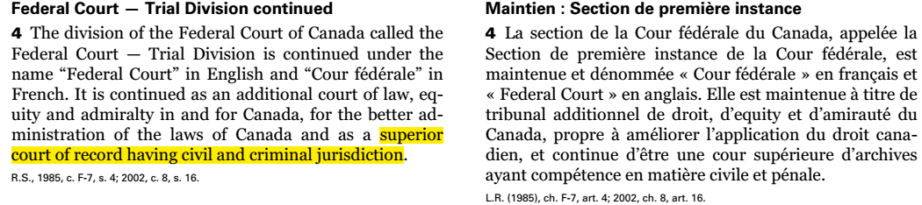
  - Her Majesty the Queen must be added as defendant in respect of Mr. Debski in his capacity as servant of the Crown for his utterance of threats.
    - Threats are themselves indictable offences under Criminal Code s. 264.1.
    - There is no distinction in jurisdiction between uttering threats and committing fraud, therefore allowing the Crown to be added with respect to Mr. Debski's alleged offence, but not with respect to the other officers' offenses is nonsensical, and it follows that the Crown will be added with respect to all of Her Majesty's servants named in the existing claims in the action.

The plaintiff concludes that the Court is not bound by the Federal Court of Appeal's reasons on either motion, but may rely on them as jurisprudence, to the extent it finds them useful.

Duress

The Plaintiff has requested Mr. Justice Gleeson to recuse himself from this proceeding on several occasions prior, and considers him an unjust, unethical, and corrupt judge. Given Mr. Justice's insistence that he is “seized” to the proceeding, that he will be the only judge involved in the proceeding until its is able to dismiss it, the Plaintiff's is effectively hostage to Mr. Justice Gleeson's will. Justice Gleeson has disregarded the Rules of the Federal Court, and although the Federal Court of Appeal made it clear that he does not have such a power, he continues to disregard all Rules. At present time, Justice Gleeson is acting as if he were Case Management Judge, although he was not appointed as such. When the Plaintiff addressed him as “Mr. Gleeson” at a “case management teleconference”, on the ground that he is not properly the Court, since he was not dully appointed Case Management Judge, Justice Gleeson threatened the plaintiff with consequences for “disrespect”.
The Plaintiff feels as a unwilling victim of an intellectual rapist, being forced to show “respect” to his oppressor, and is unable to make the coherent, well reasoned arguments he would make before an impartial judge. As the Justice follows rules known only to him, rather than the Federal Court Rules, the plaintiff is prevented from knowing what criteria his submissions will be evaluated by, and is prevented from researching jurisprudence in order to make the best case possible. The plaintiff is limited to throwing darts in the dark.
Given that the Justice has so far disregarded the Rules of the Court, and continues to do so, and given that as explained above, the Plaintiff believes no additional representations were necesssary at all, in respect to the Motion for Summary Judgment, the Plaintiff understands that the Justice is in fact attempting to negotiate the contents of his second determination of this motion, in order to find language that the Plaintiff would not appeal a second time, while still delivering the result that the Defendant requested. The Plaintiff feels he is faced with the impossible task of persuading a judge who has already made his decision, but has not yet found the optimum delivery.
It is in this oppressive context, owing solely to Justice Gleeson's conduct, that the Plaintiff makes these submissions under duress.

Under duress,

Radu Hociung - Plaintiff

